**Online Recruitment System**

TABLE OF CONTENTS

|  |  |  |
| --- | --- | --- |
| Sr no | Title | Page |
| 1 | Introduction | 2-3 |
| 2 | Literature Survey | 4-5 |
| 3 | Analysis | 6-8 |
| 4 | Design | 7-14 |
| 5 | Implementation | 15-29 |
| 6 | References | 29 |

**Introduction**

Job Portal is an application which connects company and candidate where company are the source of the resources and the candidate can find and apply for the desired job. This document provides the entire information regarding this project. This project aims in providing right candidate to the company and desired job to the candidate. This project will provide the information of job vacancies in the company, candidate and search for a desired company and can check the post available to apply. Once a candidate has applied for a job to the respected company, the company can check his/her profile and can send the feedback under review or reject depending on the resume. Company and candidate both can update their profile. The functions that this project include is:

* Separate login page for both candidate and Company.
* Separate registration form for both Company and Candidate.
* Job Search option.
* Dashboard of both Company and Candidate.

This project is user friendly as it has used simple interface and easy to understand. It is reliable as all the data given in this project is real and it is easily accessible as anyone can access it anytime and anywhere.

**Problem Statement**

There is no automated Recruitment System which provides quick operation response and which saves time.

**Scope of the Project:**

The proposed project will check the activities of candidate, organization etc.

The system fulfills all the functions as the proposed system.

It will reduced the time response and will also reduced the no of queries of different users.

The admin will have the information of vacancies in a company, no of candidates who have applied and those who all are selected.

Verification, validation, security, user friendliness will all be done in this project.

**Refine solution**

The first step of system analysis involves the identification of need.

First the candidate has to register himself/herself in order to access the full site.

Registered candidates should be eligible to apply the available jobs only if the requirements matches with their skills.

The registered candidate has to fill their details.

The admin will collect the data from the users and is responsible to post the job requirements along with the criteria.

The admin is the mediator between the candidates and the company.

Normalize database should be maintain which yields consistent results.

**OBJECTIVES**

The main objective is to provide service to both Employer and the candidate by recruiting candidates according to the grades and skills.

The company or the employee are able to recruit the candidates according to their specification.

To let the candidates know about different jobs offer.

**Solution Adequancy:**

If the entire process of ‘Recruitment' is done in a manual manner then it would takes

several days for the recruitment. Considering the fact that the number of applicants for

recruitment is increasing every year, an Automated System becomes essential to meet the

demand. The problem will be solved when 90% of the parameters are satisfied by the organization

then that candidate is hired.

Literature Survey

The struggle in the universal market provides a business to overwhelm the people to look for something which has different strategies. So many organization purposefully implement e recruiters for their benefits. Online recruitment system has become the main platform nowadays with growing marketing and communication over the internet. Many companies use e Recruitment to post jobs and accept resume on the website. It has shown great benefits to IT and CS engineers. The main success of the e recruitment are the value added servies provided by job sites. In this way companies are able to provide more customized solution over a short span of time.

**Research Papers:**

1.<https://www.researchgate.net/publication/268210664_A_Study_On_Recruitment_Selection_Process_With_Reference>

2.<https://www.academia.edu/1291573/A_Study_of_the_Recruitment_and_Selection_process>

3.<https://www.theseus.fi/bitstream/handle/10024/123598/Mariia_Bogatova_Thesis.pdf?sequence=1>

4.<http://www.ijsrp.org/research-paper-0415/ijsrp-p40133.pdf>

5.<http://www.iosrjournals.org/iosr-jbm/papers/Vol15-issue5/H01556067.pdf>

**Comparison Of Research Papers**

|  |  |  |  |  |
| --- | --- | --- | --- | --- |
| Research Gate | Academia | Thesus | Ijsrp | Iosjournals |
| The main objective of this paper is to identify general practices that organizations use to recruit and select employees | The main objective of this paper is to identify general practices that organizations use to recruit and select employees. | The main objective of this study was to evaluate the current Human Resource Management processes in the case company | The main objective of this paper is To identify the average time spent for selection process and to assess the perception of the employers regarding recruitment process they have undergone | The main objective of this paper is to identify general practices that organizations use to recruit and select employee |
| This research paper mainly focus on the study of the recruitment and Selection process | This research paper mainly focus on the study of the recruitment and Selection process | The research was focused on recruitment channels, selection methods and retention tools for small-and-medium-sized companies | This research paper mainly focus on the Selection Process of the candidates. | This research paper mainly focus on the Selection Process with reference to other companies. |
| It focuses on the analysation of the recruitment and selection process in industries and about the recruitment sources used by them and also the employee satisfaction level with existing industry policy | It focuses on the identification of the general practices that organizations use to recruit and select employees and how these selection practices affect organizational outcomes. | It focuses on the human resource management techniques used in the small and medium sized companies and also how the recruitment process is carried out in these industries. | It focuses on the understanding the and selection processes in organization and analysis of manpower budget for the recruitment process and to identify new ways of improving the present recruitment procedure. | It focuses on the various requirements sources used by the industries and to study the stages of selection procedure in the industries. |

**Analysis**

**User Stories and Priorities**

**Goal: Finding Suitable Company for applicant through this application**

**Rolls of Actors in User Stories:**

1. Applicant:- This website will help applicant for finding out suitable company having reasonable package and to do other Job related work.
2. Admin:- Manages the website such as taking information about applicant and sending the company details for applicant for placement and others job related work. It will act as a buffer for managing applicant and company.
3. Company:- They will use this website for acquiring information of the applicant view their profile send their company information for such as timing , venue and selection round details to applicant via admin.

**Priority for User Stories:**

The user stories has provided priority for each case. In which for ex. **Priority ‘1’** will indicates ‘**Lowest priority’**, whereas **Priority ‘5’** will indicates ‘**Highest priority’.** And risk factor are ranged from **Low to High** depending risk involved in that case

|  |  |  |
| --- | --- | --- |
| **User Stories** | **Priority** | **Risk Factor** |
| 1. As an Applicant I want to know the different companies offering jobs so that I can know in which companies to apply. | 5 | Medium |
| 1. As an Applicant I want to know the company’s criteria of different companies so that I can know my eligibilities. | 4 | Medium |
| 1. As an applicant I want to know , which companies are providing what different types of services. | 3 | Low |
| 1. As an applicant I want to know the pre placement talk of the companies. | 2 | Low |
| 1. As an applicant I want to know the numbers of alumni working in the company so that I can know more about them. | 1 | Low |
| 1. Admin managing All the informations for applicant and   company | 5 | High |
| 1. As an applicant I would like to get  notification about research topics of my interest from various companies so that I can apply to them. | 3 | Medium |
| 1. As a company/Organizer I want to know the profile of the candidates so that it will help to shortlist. | 5 | High |
| 1. As a company/Organizer I want to use resume scanner so that it will filter the resume through predefined criterias and requirements. | 4 | High |
| 1. As a company/Organizer I want to know about their institution so that i will come to know about their degree and level of education | 3 | Meduim |

**Sequence Diagram**

Applicant

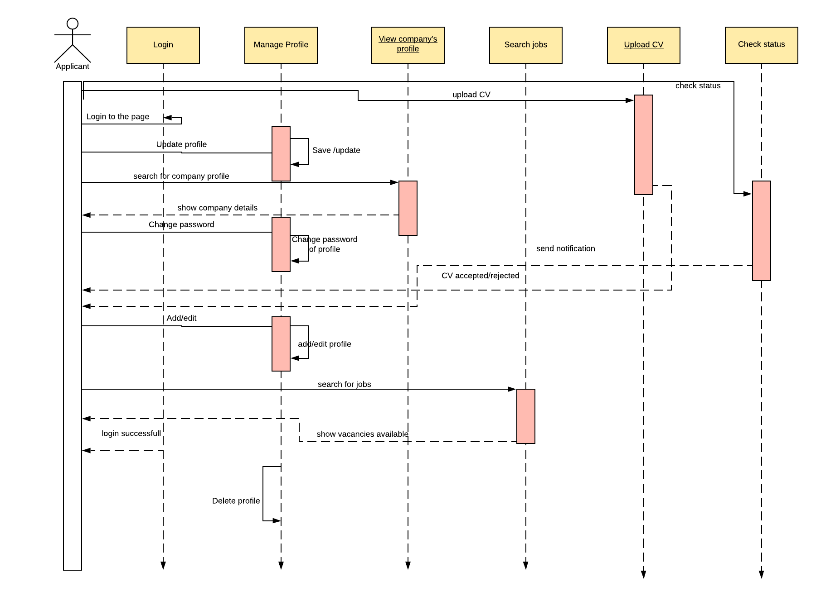

**Company**

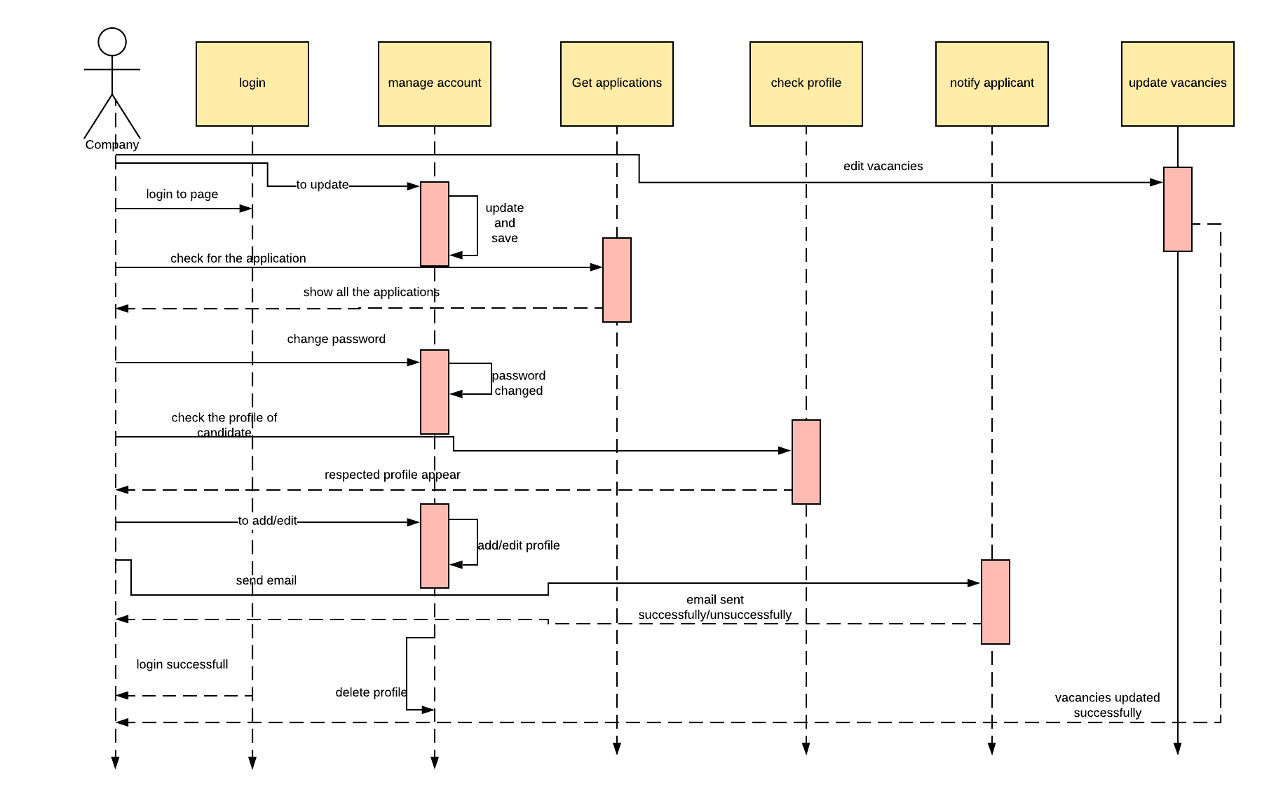

**Admin**

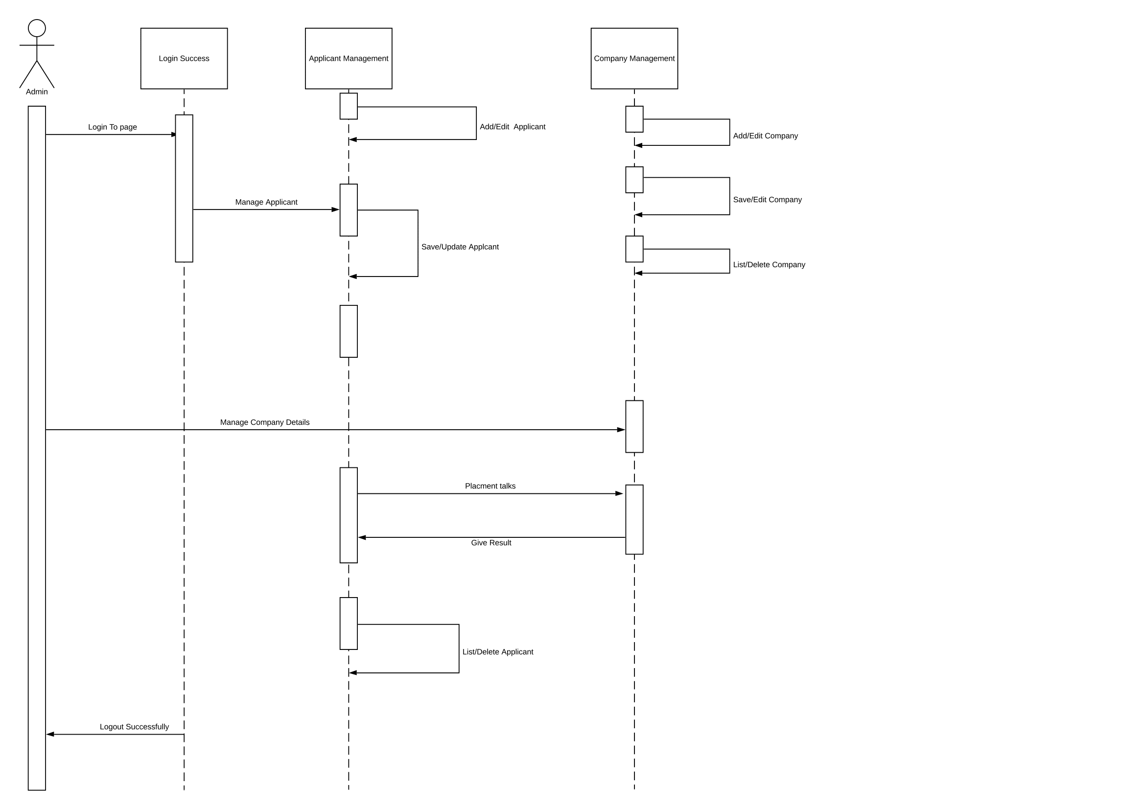

**Design**

**Class Diagram**

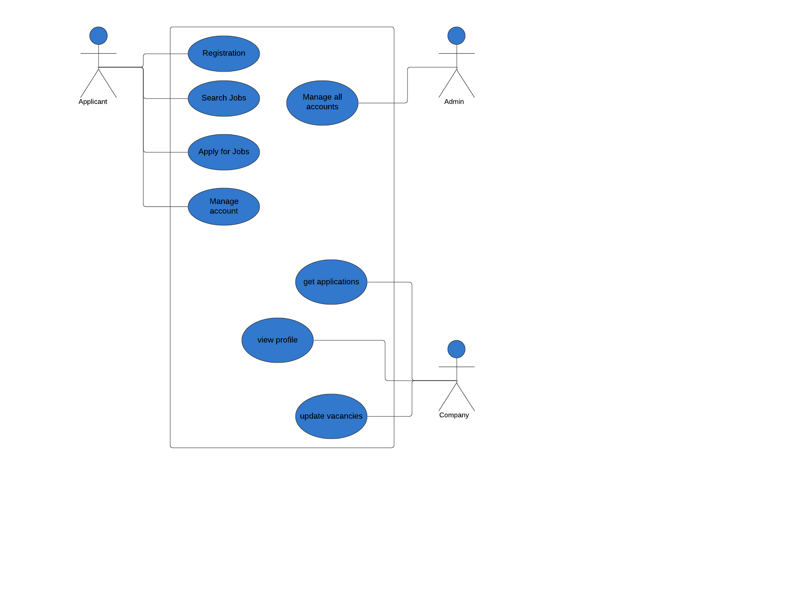

**Use Case Diagram**

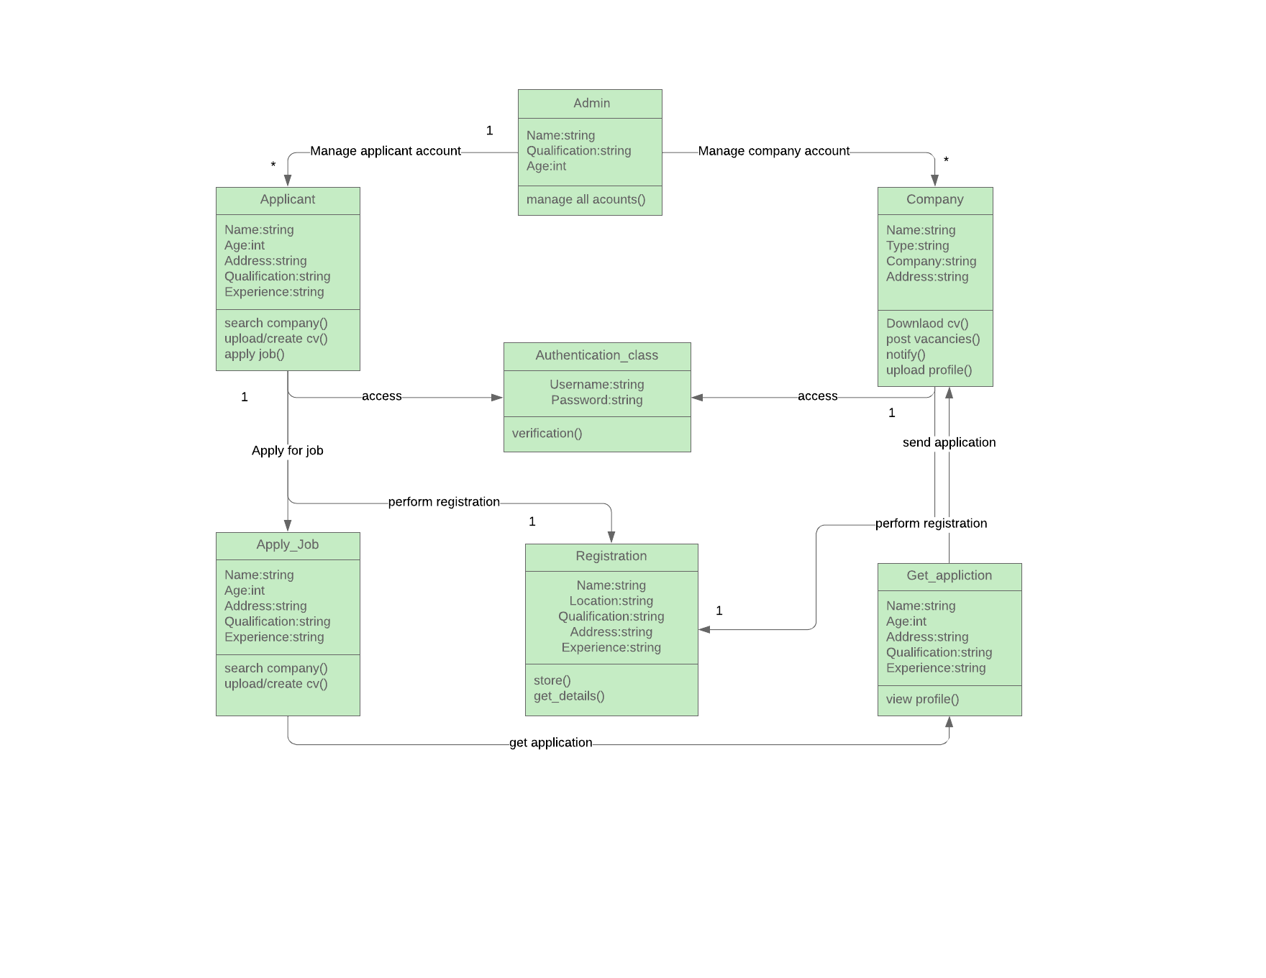

**Technology Stack**

|  |  |  |
| --- | --- | --- |
| User Stories | Technical Stories | Acceptance Criteria |
| As an Applicant I want to know the different companies offering jobs so that I can know in which companies to apply. | In order to know the companies, the database should have the list of all the companies using SQL and display it to the user. | If the user is able to see the available comapnies , then this criteria is accepted |
| As an Applicant I want to know the company’s criteria so that I can know my eligibilities. | System A must fetch the criteria list of the company using SQL and show it to the user | If the applicant fulfill the criteria then he/she is selected. |
| As an applicant I want to know , which companies are providing what different types of services. | System A should take the information of all the services of the company and display it to the user. | System A should take the information of all the services of the company and display it to the user. |
| As an applicant I want to know the numbers of alumni working in the company so that I can know more about them. | System A will retrive the information of the alumni who works in that company and will display it to the user. | If the search list match then the user is able to see the list of alumni or else it will display ‘not found !!’. |
| As an applicant I would like to get  notification about research topics of my interest from various companies so that I can apply to them. | System A should fetch all the research topic from the database of company and display it to the user | If the user is able to view the topics of interest then the criteria is accepted. |
|  |  |  |
| As a company/Organizer I want to know the profile of the candidates so that it will help to shortlist. | System A will get the information from System B regarding Profile and display it to the user using interface C | If the company is able to view the list then the criteria is accepted. |
| As a company I want to use resume scanner so that it will filter the resumes through pre-defined criteria’s and requirements | System A will Scan the requirements from system B and will display it to the company | If the company is satisfy with the scanner then the criteria is accepted. |
| As a company I want to know about their institute so that I will come to know about their degrees and level of education. | System A will retrive the information regarding the institution name from the database . | If the company is able to view the institution name then the criteria is accepted |
|  |  |  |
|  |  |  |

|  |  |
| --- | --- |
| Technical Stack | Proficiency |
| **Frontend**  1.HTML,css,bootstrap  2.Angular  3.React Native | Expert  Intermediate  Beginner |
| **Database**  1.MySQL  2.Firebase  3.MongoDB | Expert  Intermediate  Beginner |
| **Backend**  1.PHP  2.Python  3.Javascript  4.node.js | Expert  Intermediate  expert  Intermediate |

Rationale technology stack

1.Fronend

**HTML,CSS**: We will use this technology as a frontend as as it implemets the structure, design, behaviour, and animation of everything you see on the screen.

**Bootstrap**: Because we want to make our website responsive, mobile-first project with HTML and CSS.

2. Database

**MySQL**: We will be using MySQL because of High Speed of processing data, use of triggers increases productivity, with rollback and commit helps in data recovery if required.

3.Backend

PHP: We will be using PHP because when a PHP page is requested, the server parses the PHP code, which in most cases results in dynamically created HTML.

**Implementation**

**Homepage**

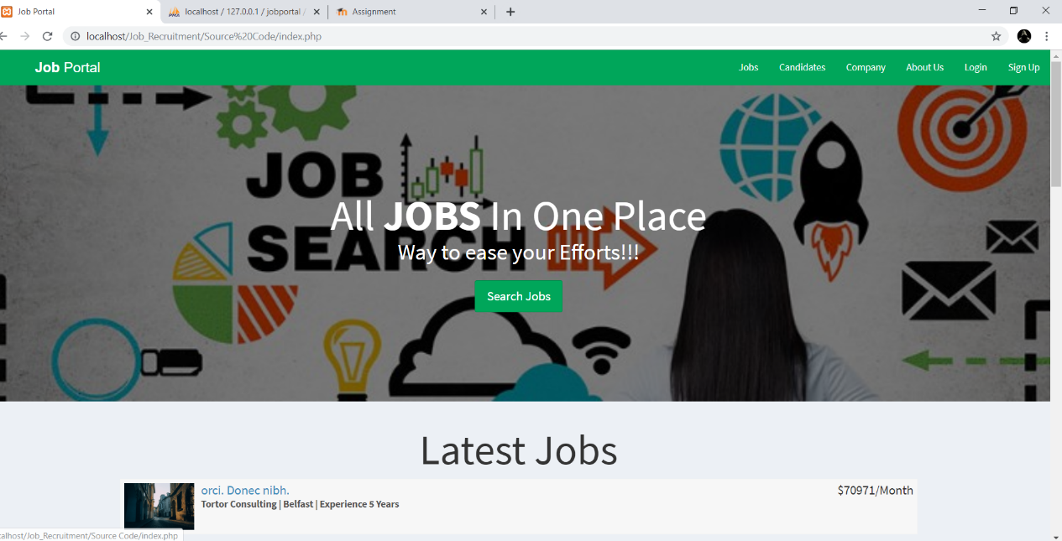

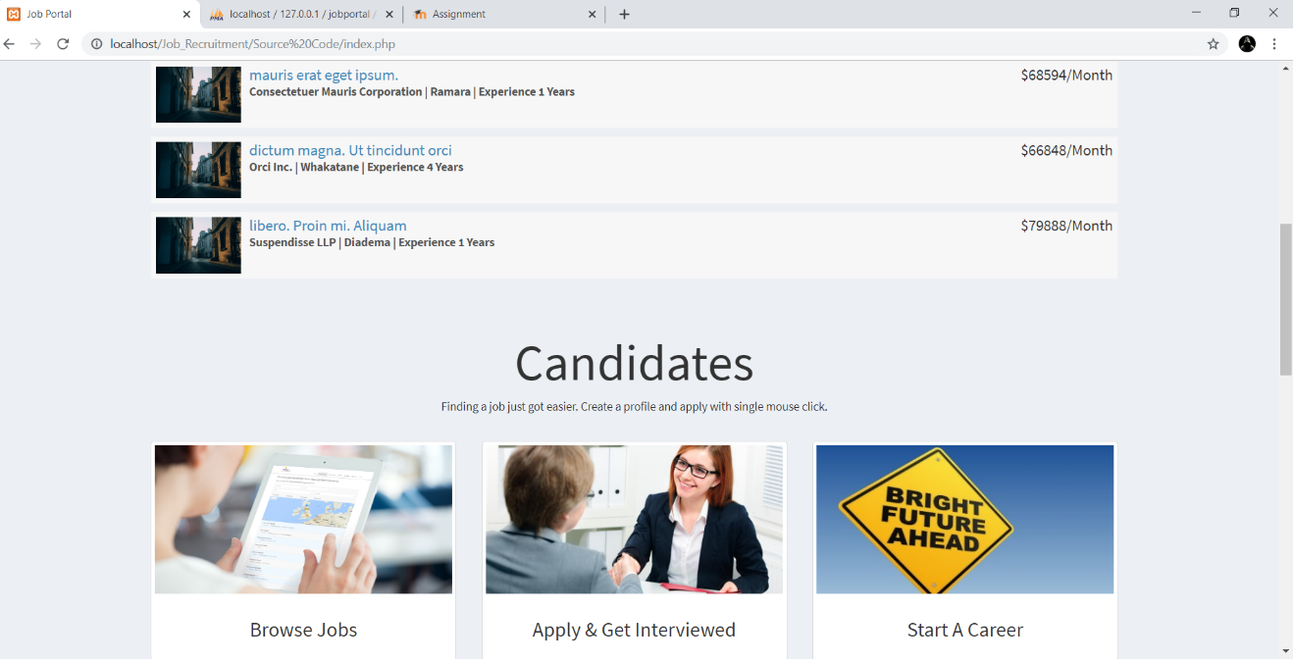

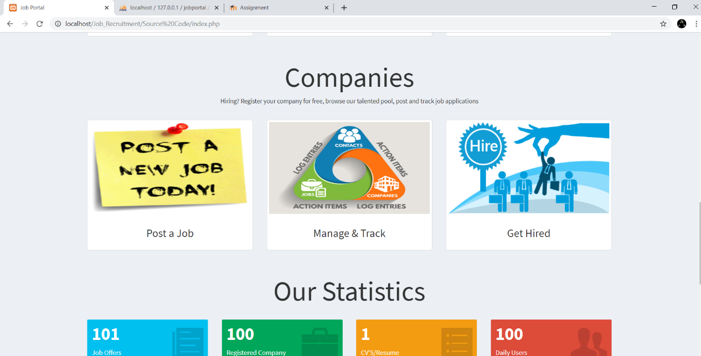

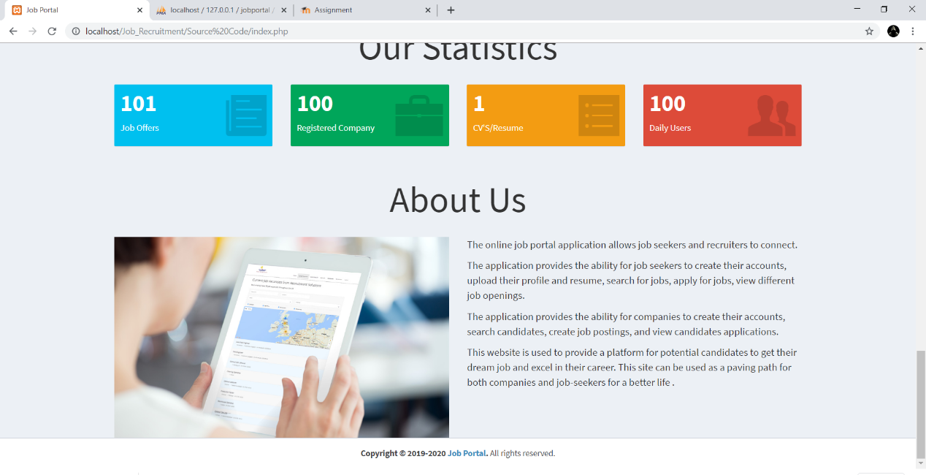

Login Page

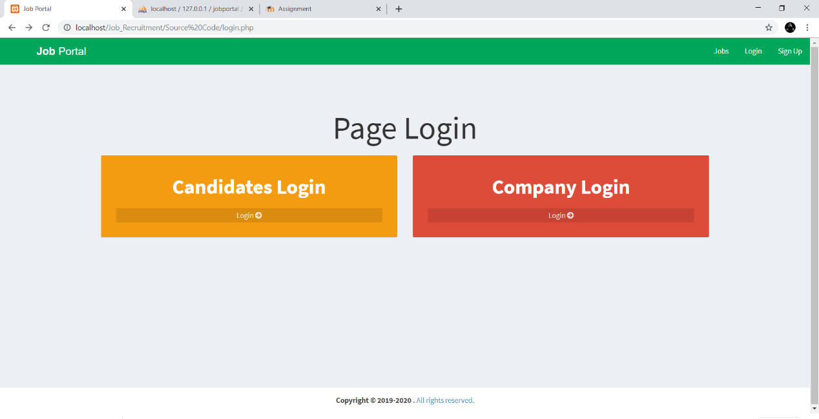

Sign Up Page

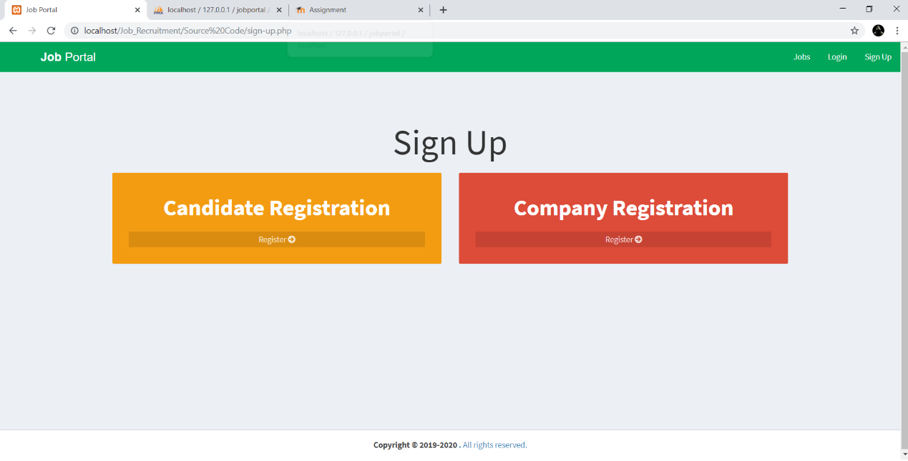

Job Search List

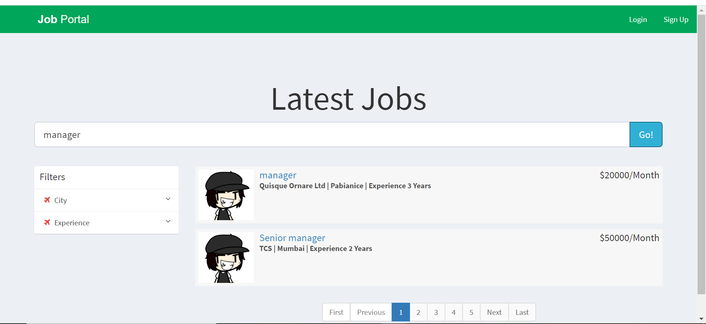

FRONTEND AND BACKEND

Company Dashboard After Login

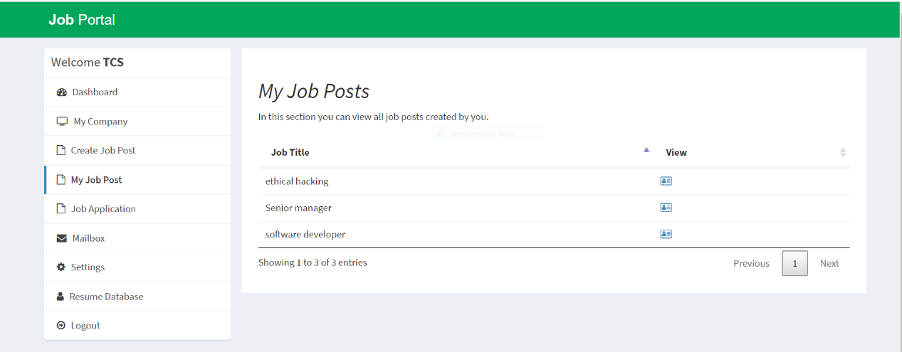

Company Job Application List

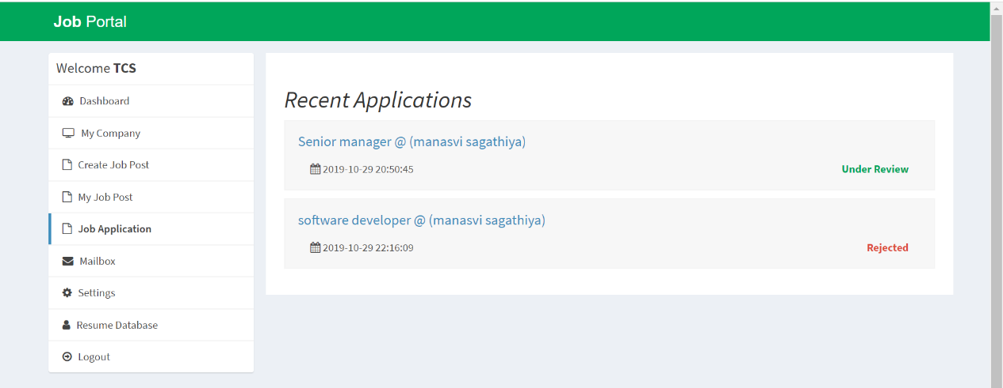

Job Status about Job available and Application

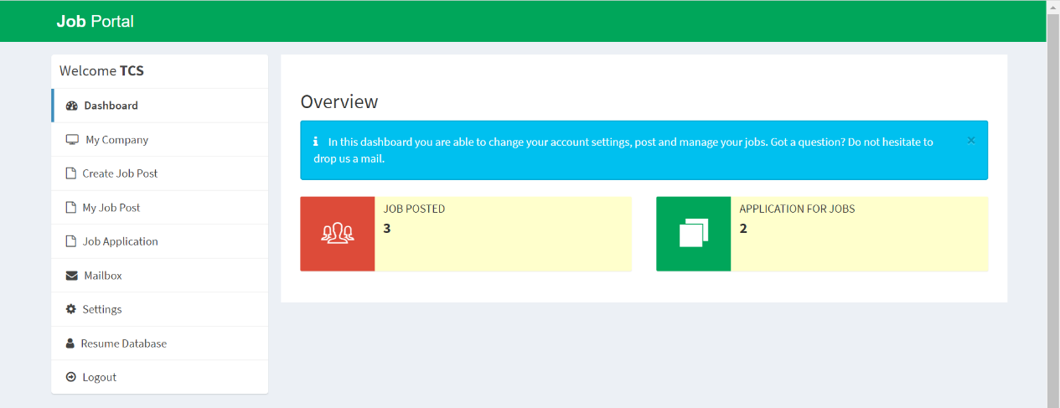

Candidate Dashboard After Login

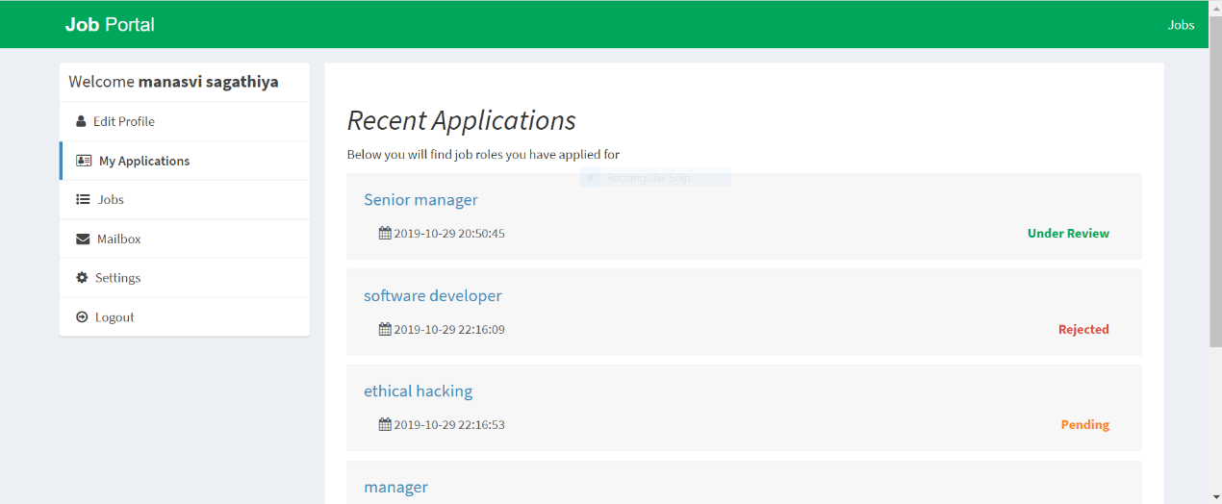

Candidate applying for job

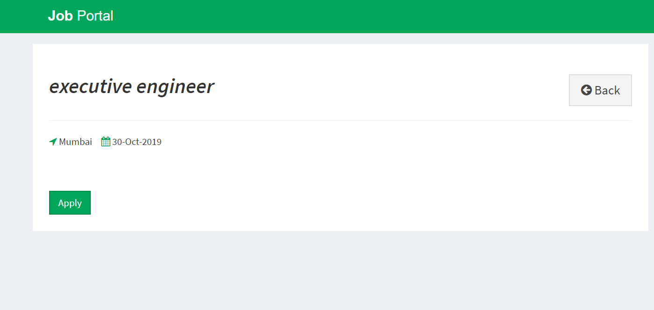

Edit Candidate Profile

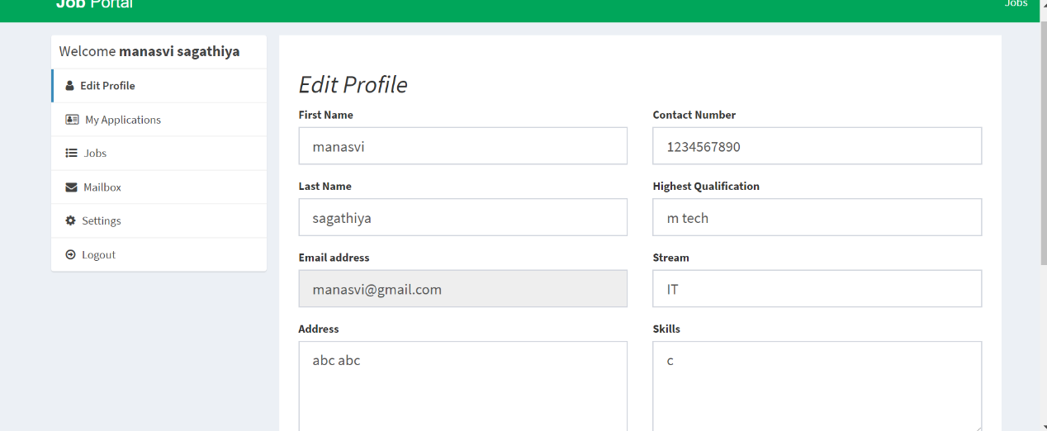

Backend

Create database name ‘jobportal’

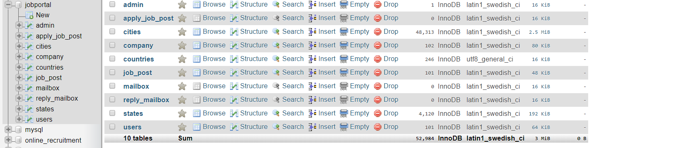

ADMIN

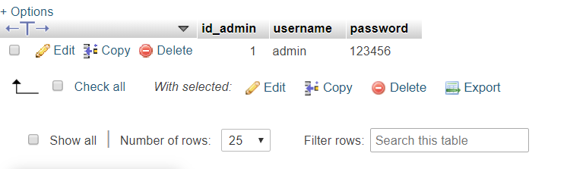

Cities

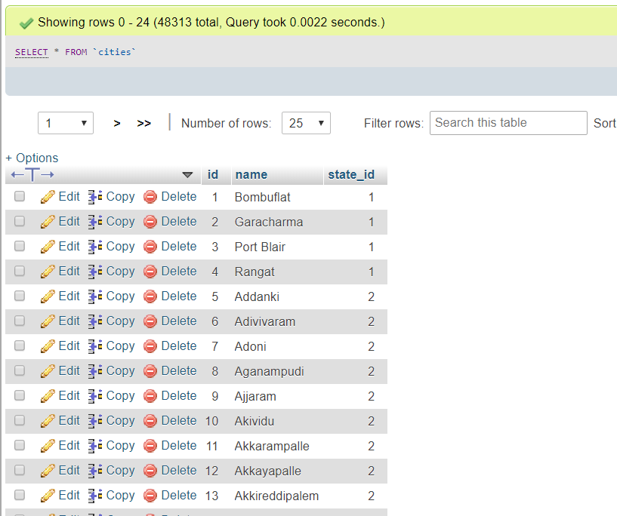

States

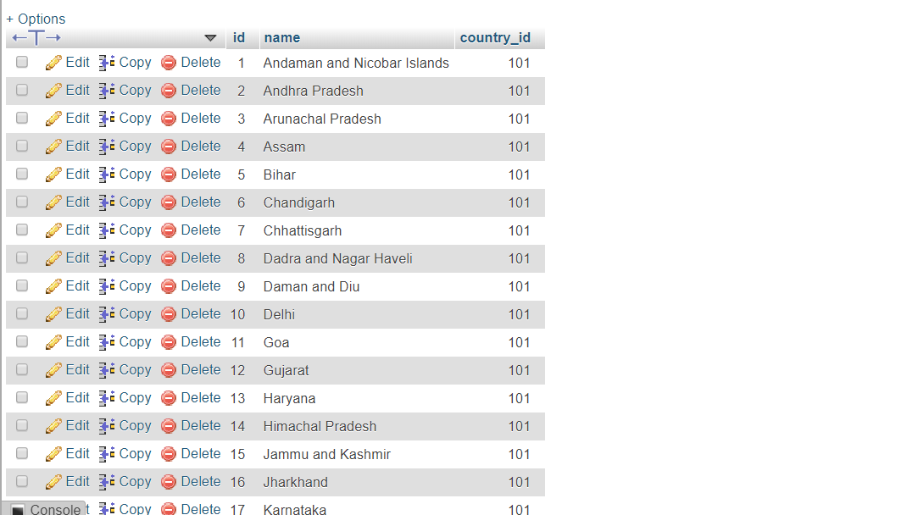

Users



Company



**INTEGRATION AND TESTING**

**Introduction:-**

Online Recruitment System is a web application that helps to recruit the candidates for the their Dream Company.Allowing them to search jobs,faclities and more.And also Company can also hire candidate,reject them if they are unstable for them so basically it is a two way system.In which Admin acts as an interface between them.

**Libraries and API used:-**

1. JQUERY:-

jQuery is a fast and concise JavaScript library created by John Resig in 2006. jQuery simplifies HTML document traversing, event handling, animating, and Ajax interactions for Rapid Web Development.jQuery is a fast and concise JavaScript library created by John Resig in 2006. jQuery simplifies HTML document traversing, event handling, animating, and Ajax interactions for Rapid Web Development..

1. CHARTIS.js-

Chartist was developed for a very particular need: to create simple responsive charts. While other charting libraries do a great job of visualizing data, something is always missing to satisfy this simple yet demanding need.

1. Toastr:-

**toastr** is a Javascript library for Gnome / Growl type non-blocking notifications. jQuery is required. The goal is to create a simple core library that can be customized and extended.

**Software Testing Application:- Test Complete 14**

**TEST 1:- To test working of Login Form for Candidate**

Step 1:- We will first manually do the operations By using Record Keyword Test option which will record our keystrokes and actions.

Step 2:-The recorded test values are stored in project Workspace which shows event occurences.

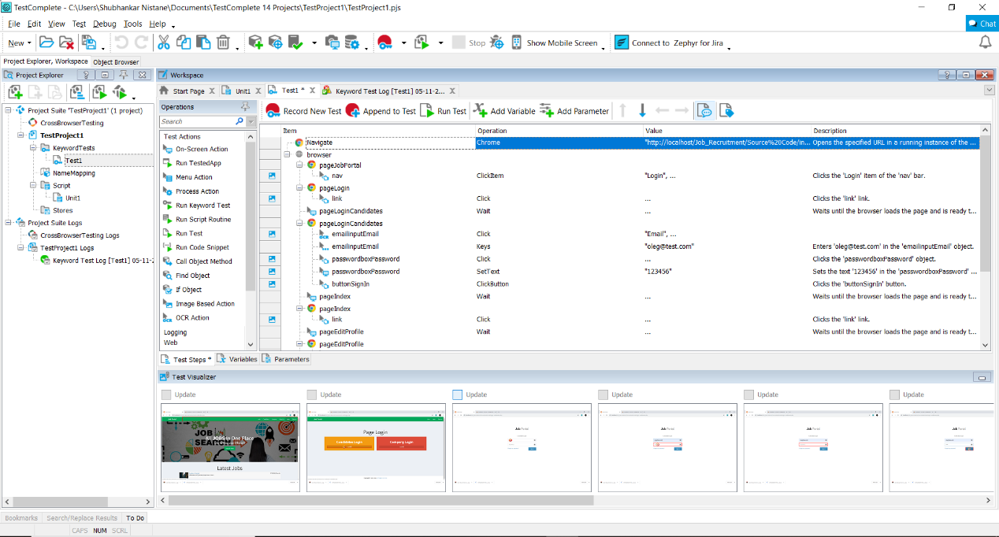

Step 3:- Shows the recorded actions perfomed on the webpage

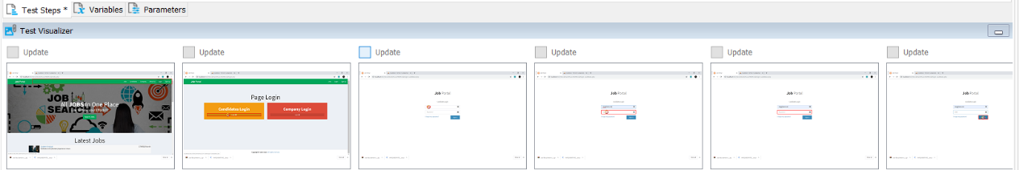

Step 4:- The keyword test Log shows the records of the functions performed by the Auto tester where the ‘green tick’ indicates that the test is run successfully.

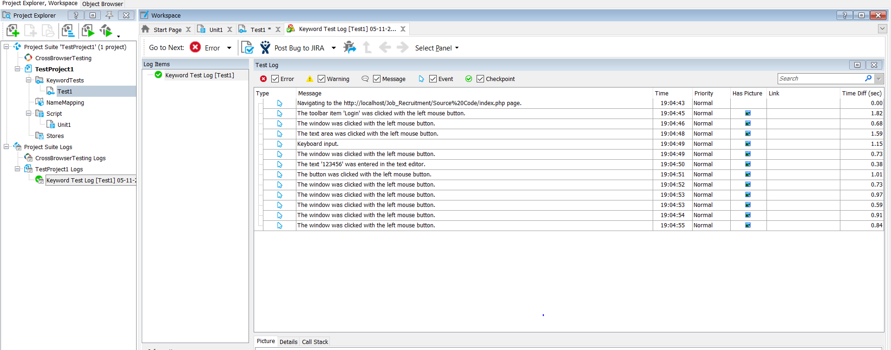

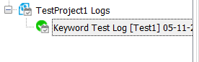

Step 5:- The recorded code can be converted into script form

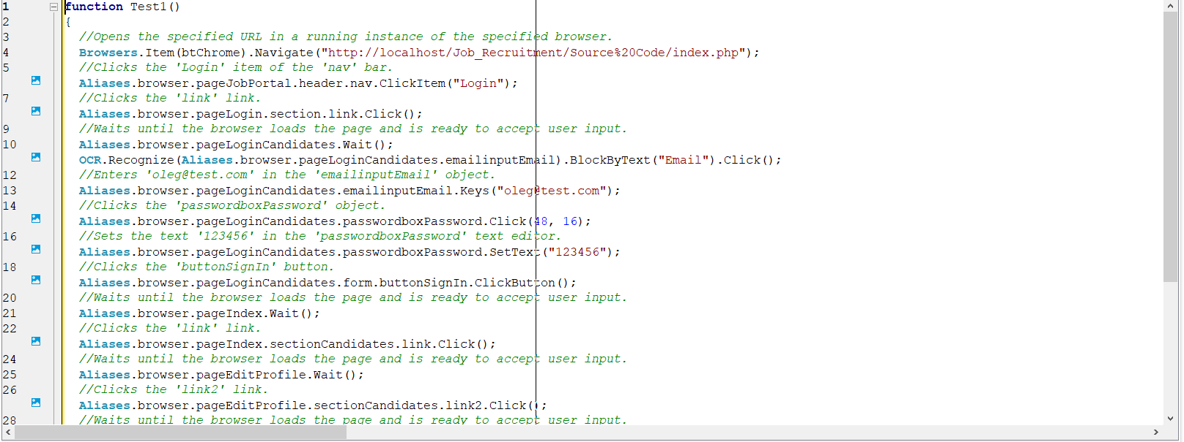

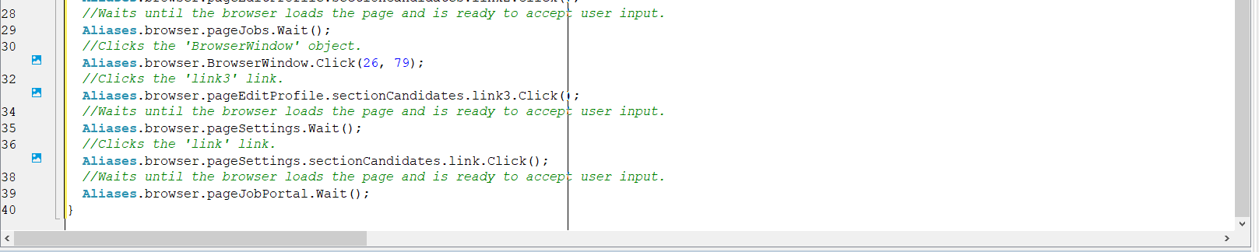

**TEST 2:- To test working of Login Form for Company.**

Step 1:- We will first manually do the operations By using Record Keyword Test option which will record our keystrokes and actions.

Step 2:-The recorded test values are stored in project Workspace which shows event occurences.

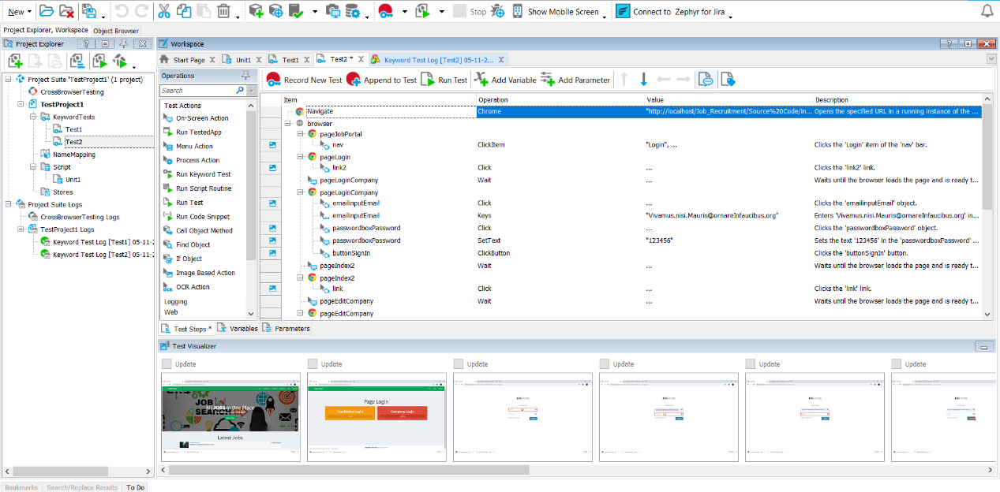

Step 3:- Shows the recorded actions perfomed on the webpage

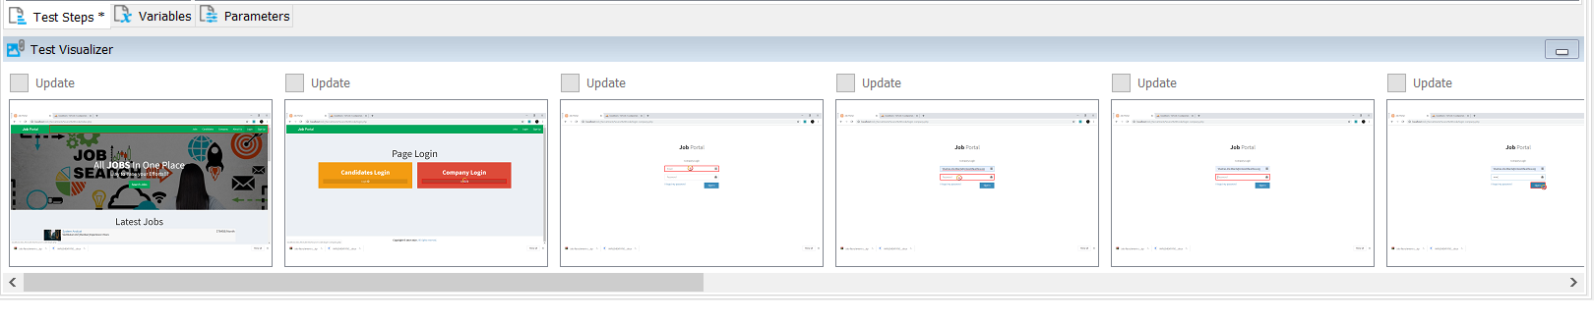

Step 4:- The keyword test Log shows the records of the functions performed by the Auto tester where the ‘green tick’ indicates that the test is run successfully.

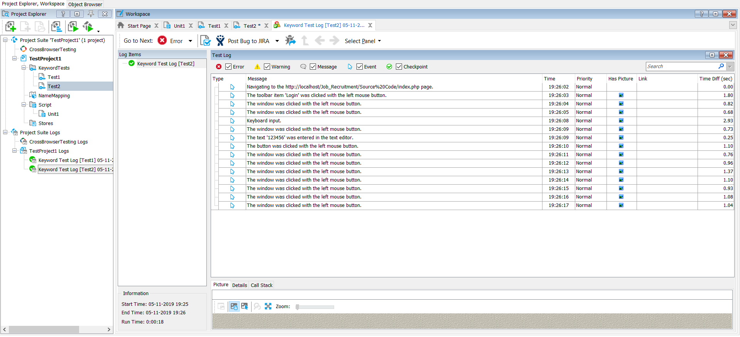



Step 5:- The recorded code can be converted into script form

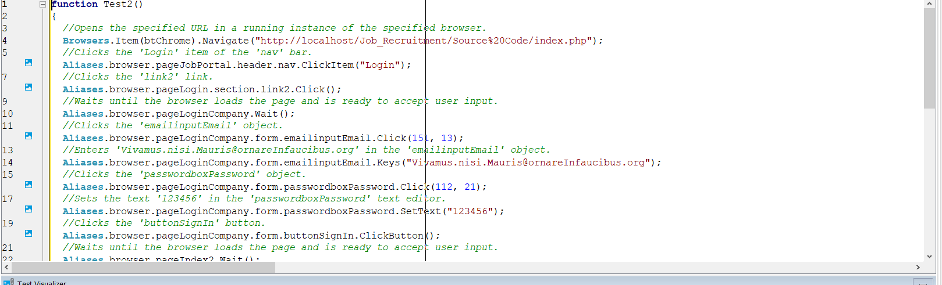

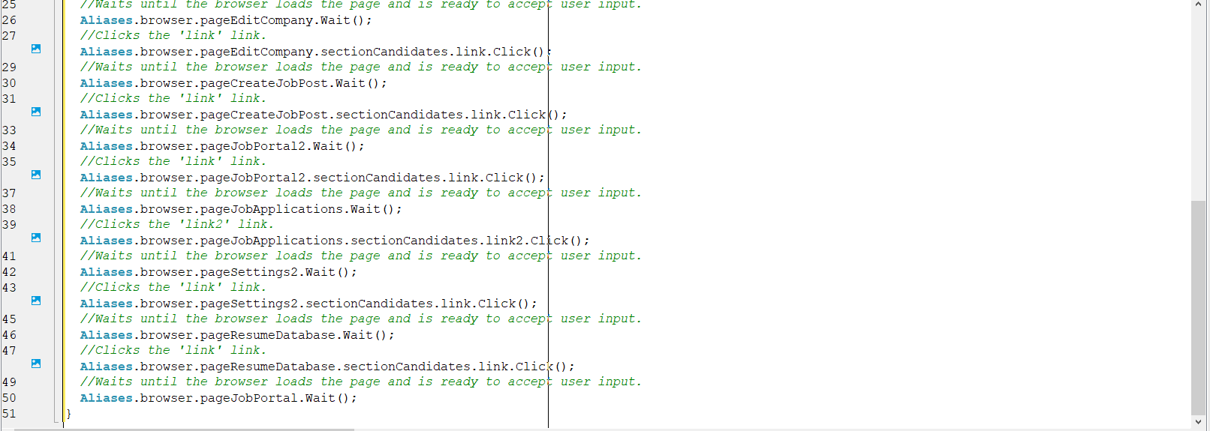

**FINAL RESULTS FOR TEST 1:-**

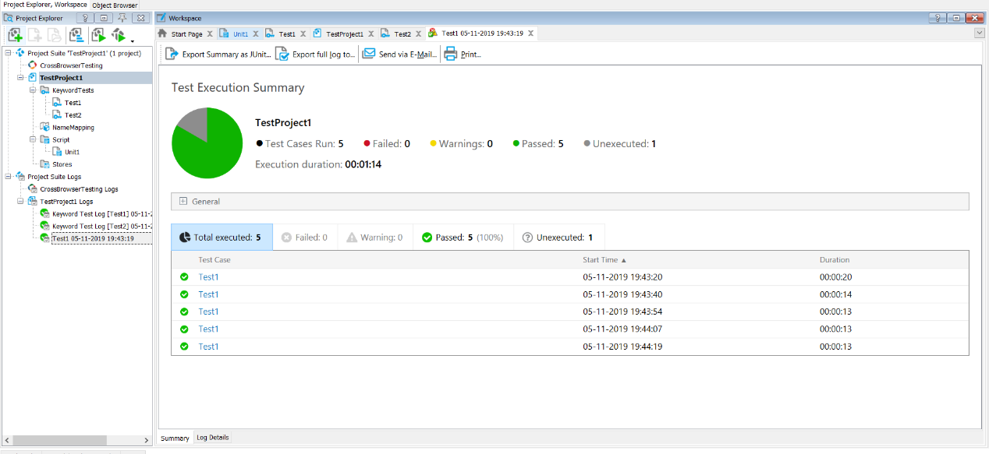

**FINAL RESULTS FOR TEST 2:-**

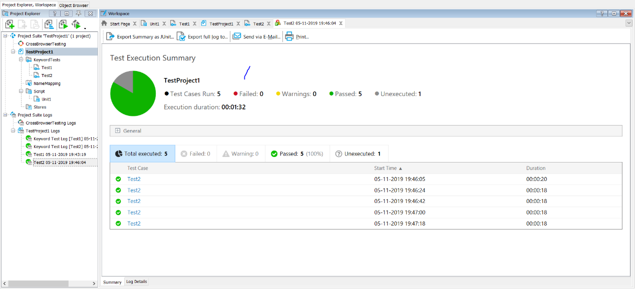

**References**

[**http://www.chennaisunday.com/Java%20Apps/Online%20Recruitment%20System.doc**](http://www.chennaisunday.com/Java%20Apps/Online%20Recruitment%20System.doc)

[**https://www.appliview.com/online-recruitment.html**](https://www.appliview.com/online-recruitment.html)

[**https://www.appliview.com/online-recruitment.html**](https://www.appliview.com/online-recruitment.html)